Introduction
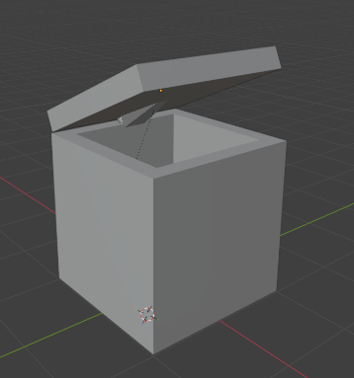
This project involved the creation of two 3D assets: a rigged humanoid character and an interactive chest. Both assets were developed in Blender and taken through a full pipeline including modelling, UV unwrapping, rigging, skinning, and export to Unity and Unreal Engine. The aim was to produce technically correct assets suitable for real-time interaction within a game environment.

Concept and Blockout
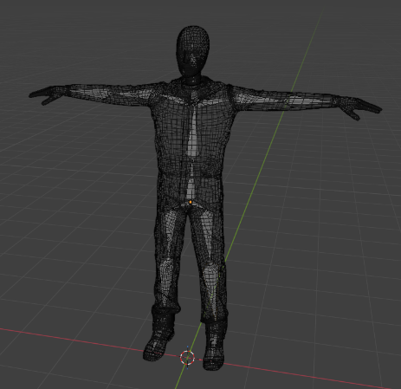
The concept and blockout stage was kept minimal to focus on demonstrating a complete asset pipeline rather than artistic detail. Both assets remain in a simplified blockout state throughout. The chest was built using two primitive cubes to maintain correct scale and proportion while keeping low complexity for rigging, skinning, and engine integration. The humanoid character was externally sourced to prioritise technical work such as UV handling, rig setup, and animation implementation. This ensured focus remained on the full workflow from modelling to engine deployment.

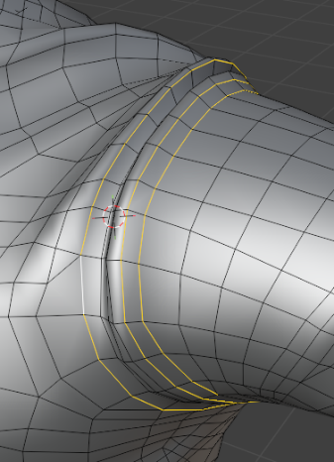
Modeling
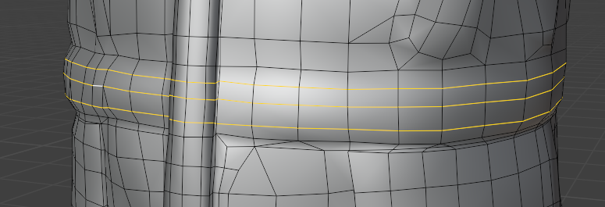
Modelling was intentionally minimal to prioritise pipeline execution over asset creation. The chest used basic cube primitives with no significant vertex editing, maintaining a clean and simple structure suitable for rigging. The humanoid character was pre-made, but minor adjustments were made for deformation. Edge loops were added around key joints such as the shoulders, elbows, and hips to improve bending during animation and reduce mesh pinching. Overall, the topology was kept clean and efficient, avoiding unnecessary complexity and supporting stable rigging and skinning.

Texture / Materials
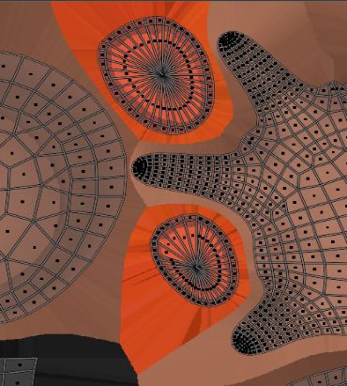
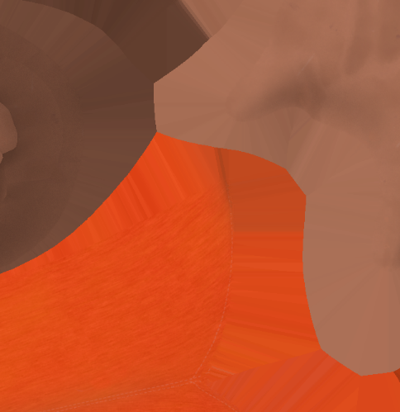
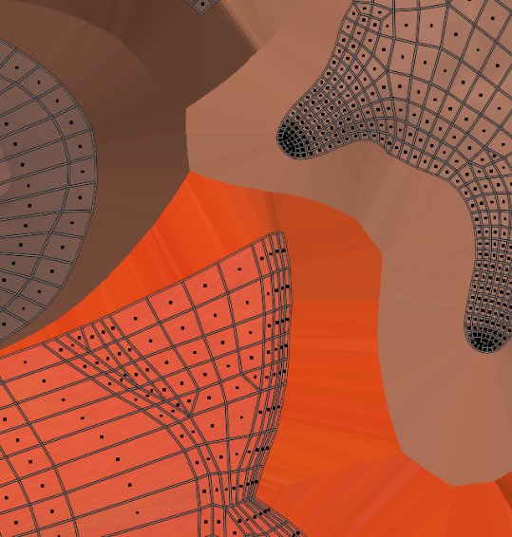
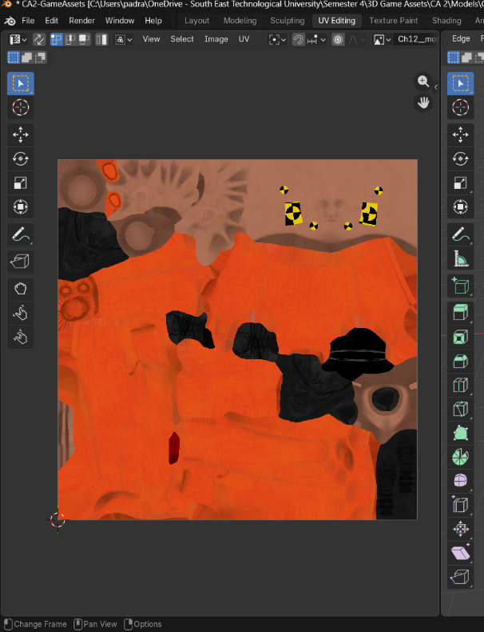
This section covers the textures, materials, and UV unwrapping used in my models. The imported model already included pre-assigned materials and texture maps, which were applied automatically on import. The UV layout controls how a 2D texture is projected onto the 3D mesh by unwrapping it into UV islands within a 0–1 space. Seams are placed in less visible areas to reduce noticeable texture breaks. The UV coordinates then map the texture accurately onto the model’s surface, ensuring correct alignment and visual consistency across the mesh.
Figure 1 good use of space and increasing size to increase the resolution of the texture

Seam

Figure 2 Where the vertexs are is actually where the UV gets wrapped onto, evrrrything else is just filler

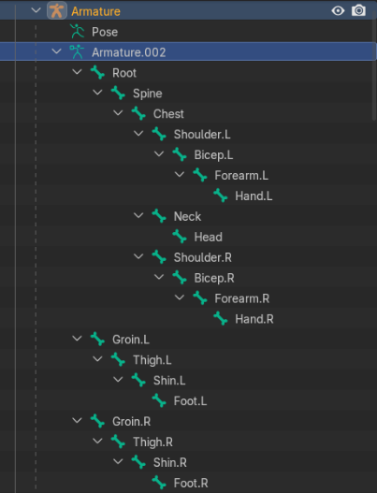
Rigging
Rigging of the humanoid model was completed using a standard bone-based armature system in Blender. The skeleton was created by extruding bones using the E (Extrude) tool, starting from a root bone placed at the base of the feet. This root bone acts as the parent in the hierarchy, ensuring all other bones inherit transformations correctly.
Joint placement was aligned to key anatomical pivot points such as the hips, knees, spine, shoulders, and elbows to support natural deformation during animation. A simple humanoid hierarchy was maintained to ensure clean parent–child relationships between bones.
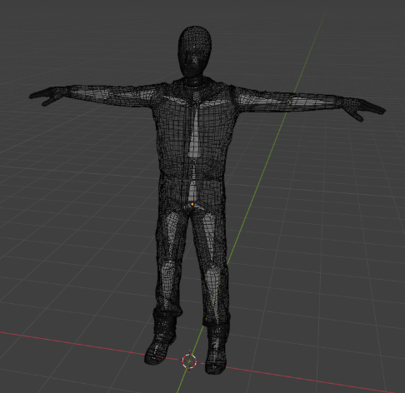
A consistent naming convention was used, with left/right symmetry automatically assisted by Blender’s .L and .R system. Bones were also manually renamed (e.g. Shoulder.L, Forearm.R) for clarity and organisation. The chest hinge was implemented as a simple bone-driven rotation joint for the lid.

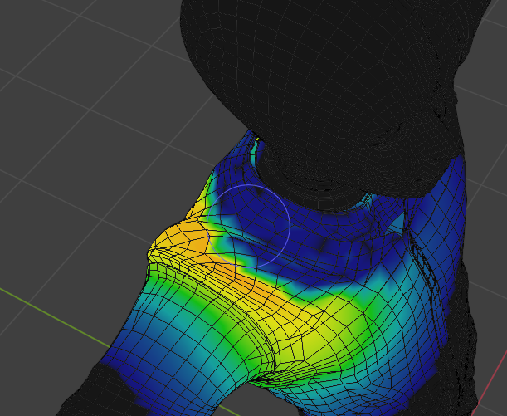
Skinning
Skinning was performed using automatic weight assignment via Ctrl + P (Armature Deform with Automatic Weights). This initially bound the mesh to the skeleton and generated influence weights for each bone.
Weight painting was then refined to improve deformation quality, particularly around high-movement areas such as the shoulders, elbows, and the wire on the back of my models neck. These areas initially showed excessive distortion, which was corrected by adjusting bone influence and smoothing weight transitions between adjacent joints.
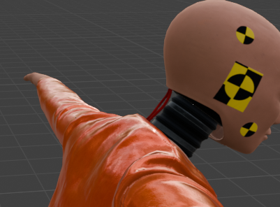
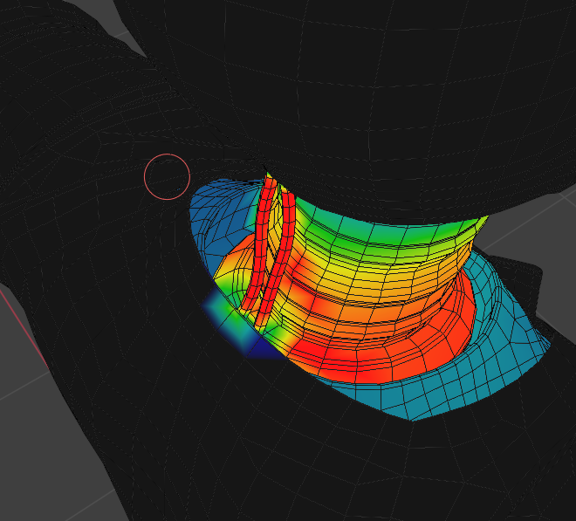
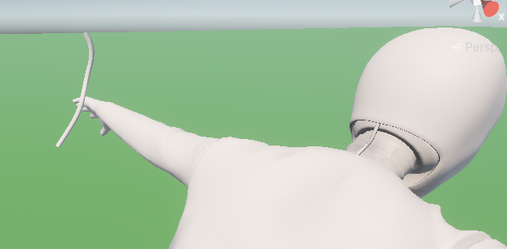
This ensured more natural bending behaviour during animation, preventing sharp creases and mesh collapse. Overall, the final skinning setup provides smooth deformation with controlled bone influence, suitable for real-time animation in a game engine.
Figure 3 After painting the weights correctly

Unity Implementation
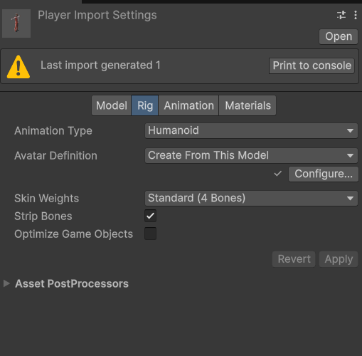
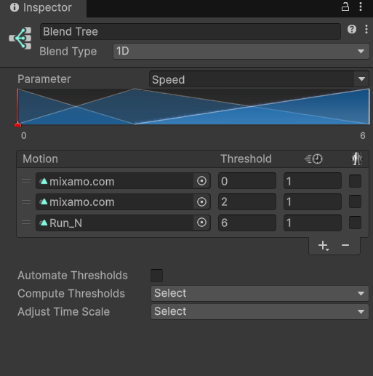
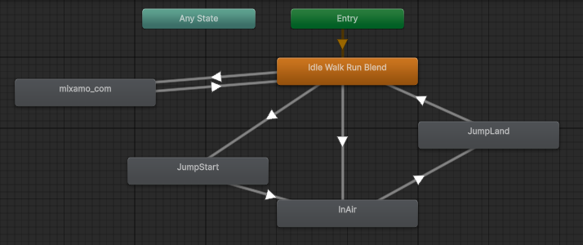
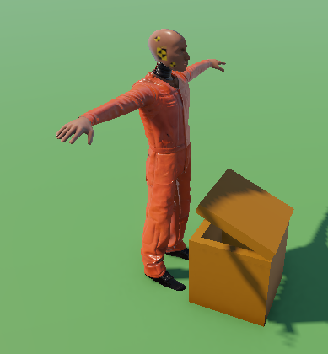
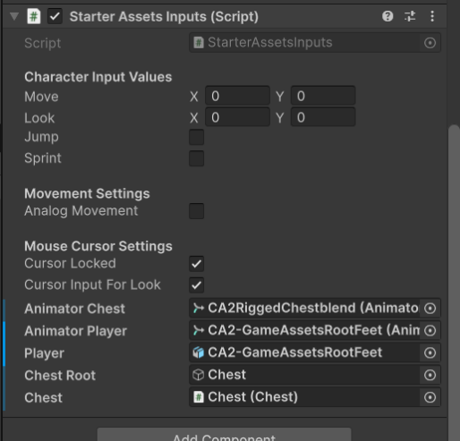
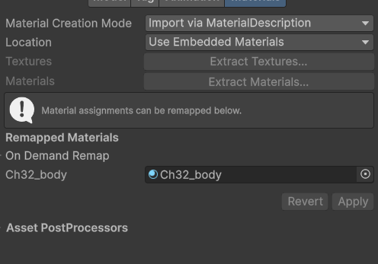
For the Unity implementation, I used the Starter Assets package for basic player movement and replaced the default model with my own rigged character, transferring the required components for compatibility. I created avatars for both my rigged model and the Mixamo models, then set up an Animator with transitions, bool parameters, and a blend tree for smoother idle-to-walk animation blending. Once everything was working, I extracted and applied the textures in Unity.

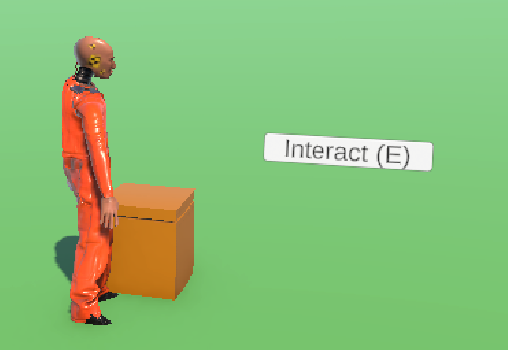
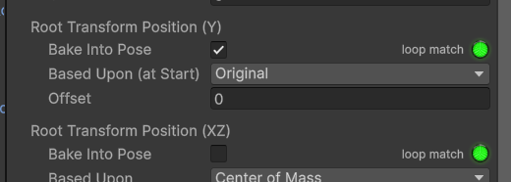
The chest was created using two cubes and a hinge bone, with the opening animation hand-animated directly in Unity. To fix player floating during the the import settings to bake the Y position into the original pose. When the presses E, the character moves into position beside the chest to improve the interaction animation animation, I adjusted.

Unreal Implementation
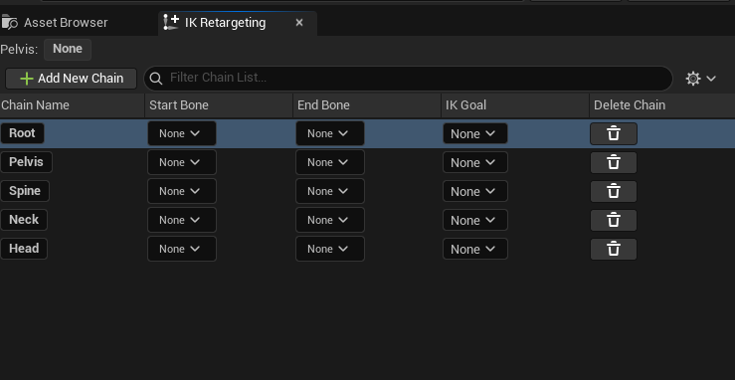
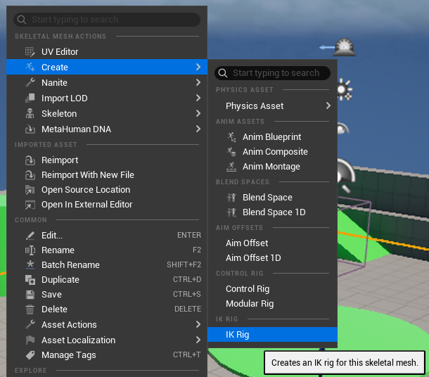
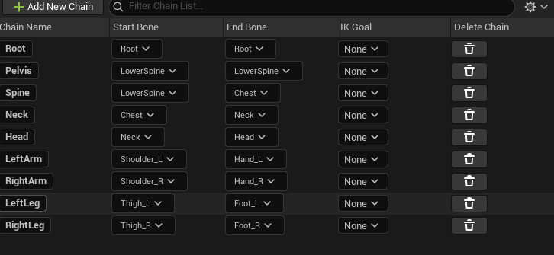
The Unreal Engine had a steep learning curve, but I got the hang of it quickly. The Unreal project included some interactive elements, featuring a movable character within a simple default scene. I imported the FBX file from Blender, and Unreal split it into three packages: the skeleton, skeletal mesh, and physical asset. To retarget animations, I had to create both a Retargeter and an IK Rig. This required manually creating rigging “chains” and assigning bones to Unreal’s designated rig hierarchy. After that, I was able to retarget the animations using the Retargeter I created, which converted them accordingly.

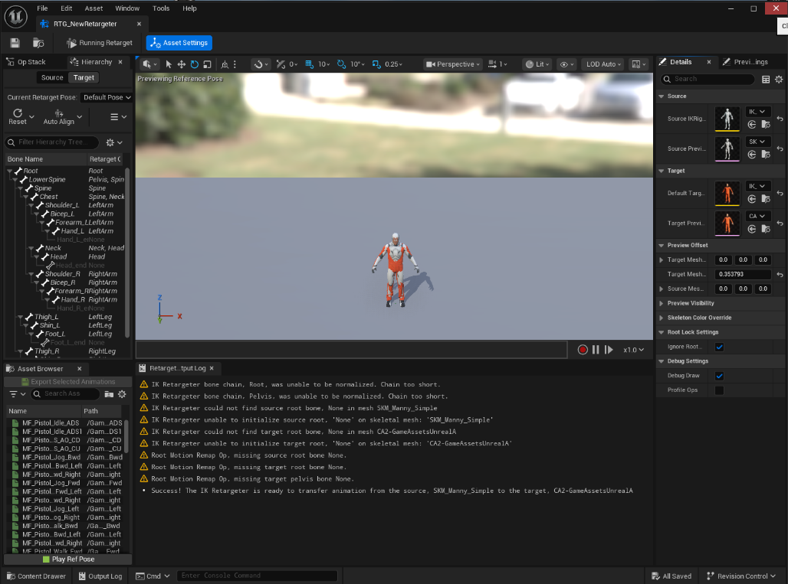
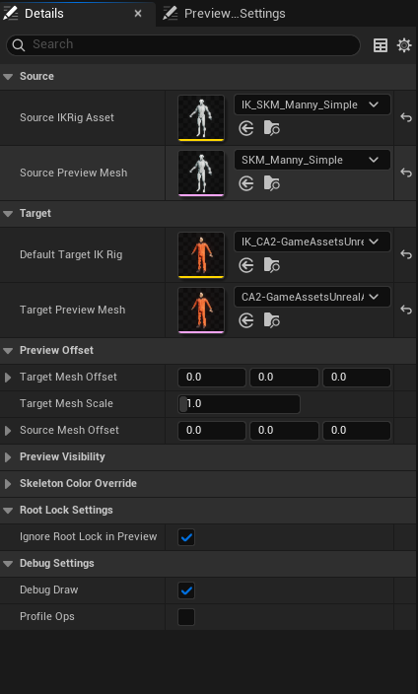
Figure 4 The ik Retargeter component

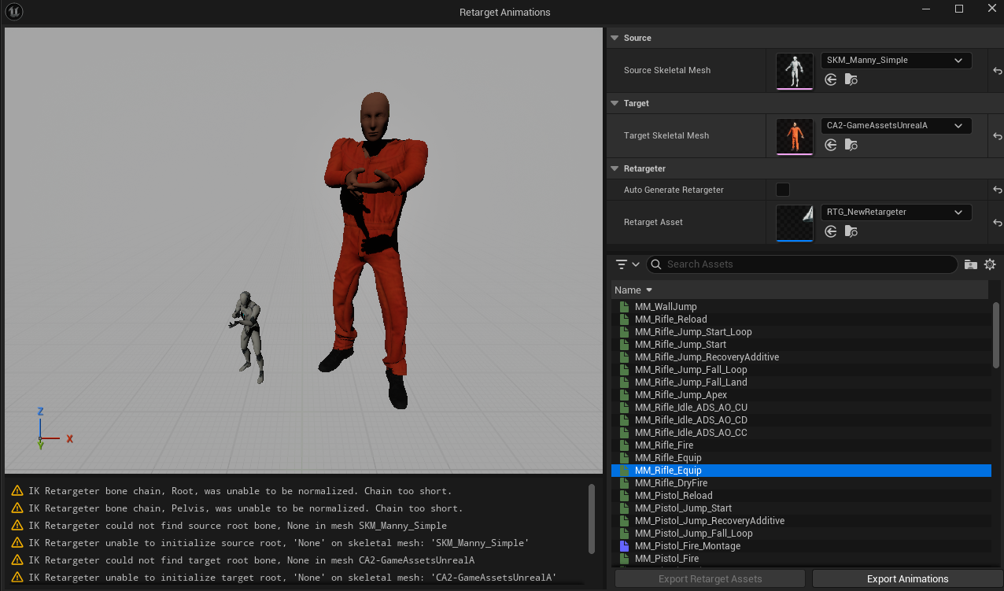
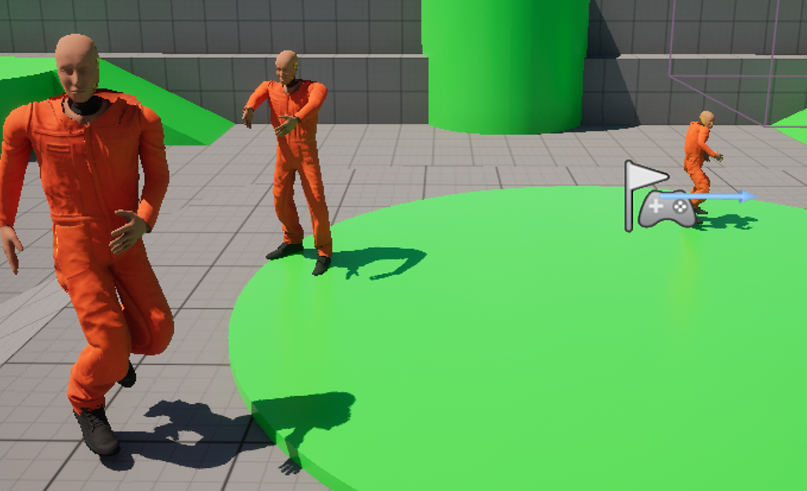Reflection & Conclusion
This project helped me develop a stronger understanding of the complete 3D asset pipeline, from modelling and UV unwrapping to rigging, skinning, and implementation in both Unity and Unreal Engine. By creating both a humanoid character and an interactive chest, I gained practical experience in preparing assets for real-time game environments and solving technical issues throughout the process.
One of the most valuable parts of the project was learning how different game engines handle rigged assets and animations. Working with animation retargeting in Unreal and animator setup in Unity improved my understanding of engine-specific workflows. I also improved my knowledge of weight painting and deformation correction, especially around problem areas such as joints and complex moving parts.
Overall, this project has improved both my technical skills and confidence in 3D game asset development. If I were to continue developing these assets, I would focus on improving the visual quality and fixing deformation and scale, while building on the technical pipeline I have established.

Video Submissions URL’s
https://youtu.be/mFbY4AkdM-0 Unity Video
https://youtu.be/UTAkin_GhqY Unreal Video

